A

MINI PROJECT REPORT

ON

<**“ Cake Shop”>**

**SUBMITTED TO**



**SAVITRIBAI PHULE PUNE UNIVERSITY, PUNE**

*In partial fulfillment for the degree Of*

**MASTER IN COMPUTER APPLICATION (Management)**

*-Submitted By-*

***Aade Sharad Sahebrao***

***Sarode Onkar Balasaheb***



Shri Baleshwar Shaikshanink Va Krishi Vikas Foundation's

**Shri Swami Samarth Institute Of Management And Technology**

(MCA DEPARTMENT)

For The Year

[2023-2024]



**CERTIFICATE**

This is to certify that Mr. Aade Sharad Sahebrao student of FYMCA, has successfully completed their project, titled “Cake Shop Website” in the Academic Year 2023-2024 in partial fulfillment of Master in Computer Application(Management) Savitribai Phule Pune University, Pune.

*Internal Examiner External Examiner*

|  |  |  |
| --- | --- | --- |
| *Project Guide* | *HOD* | *Coordinator* |

**ACKNOWLEDGEMENT**

We wish to thank the Principal **Prof. Unde A.P.** and Academic co-ordinator **Prof. Ghosale R. A.** of our college for permitting us to use all the facilities available in the institution for our project work. We would also like to thank the Head of the MCA department **Prof. Auti V.G.** the teaching faculty and all the non- teaching staff of our college for their support in completing the work successfully.

We are grateful to our Internal Guide **Prof.** **Auti V.G.** For his encouragement, guidance and supervision of our project work during the year. We express our thankfulness to them. We must acknowledge the support given to this project by **Prof.** **Auti V.G.** Without which it would have been difficult to complete the work in time.

Our classmates have been of great help to us during the project work. Our ideas were shaped and refined progressively through our discussions with them time to time. We cannot miss to thank them all. There were some persons who were not directly but indirectly involved in our preparatory/practical work. We heartily appreciate their contribution and thank them too.

**Date: 07/12/2023 Signature:**

**Mr. Aade Sharad S.**

**Class: F.Y.M.C.A.(Magt)**

**Year: 2023-2024.**

**DECLARATION**

I declare that project entitled **“Cake Shop Website”** I also declare that the project is the result of my effort and has also been not submitted to any other university or institution for the award of any degree, or personal favor whatsoever. All the details and analysis provided in the report hold true to the best of my knowledge.

**Date:-07/12/2023**

**Place:- Ahmednagar.**

**Mr. Aade Sharad S.**

**MCA (Mgmt.)**

**Index**

|  |  |  |
| --- | --- | --- |
| 1. | **Introduction** | 06 |
|  | A).Purpose of Project | 08 |
|  | B). Scope of Project | 11 |
|  | C).Overview of Project | 12 |
|  | D).General Description | 14 |
|  | E).Developer Requirements | 15-17 |
|  | i. Hardware Requirements |  |
|  | ii.Software Requirements |  |
|  | F).User Requirements | 18 |
|  | i.Functional Requirements | 19 |
|  | ii.Interface Requirements | 20 |
|  | iii.Perfrmance Requirements | 20 |
| 2. | **System Design** | 21-25 |
|  | i.DFD | 23 |
|  | ii.E-R Diagram | 24 |
|  | iii.UML Diagram | 25 |
|  | A).Sturutural Diagram | 26-29 |
|  | i.Class Diagram | 26 |
|  | ii.Component Diagram | 27 |
|  | iii.Deployement Diagram | 28 |
|  | iv.Object Diagram | 29 |
|  | B).Behaviroal Diagram | 30-32 |
|  | i.Activity Diagram | 30 |
|  | ii.Use-Case Diagram | 31 |
|  | iii.Sequence Diagram | 32 |
| 3. | **Sample Code** | 33-35 |
| 4. | **Testing** | 36 |
|  | i.Test Cases | 36 |
|  | ii.Test Results | 37 |
| 5. | **Future Scope** | 40 |
| 6. | **Conclusion** | 41 |
| 7. | **References** | 42 |

**Introduction**

The Software requirement specification is designed to document and describe the agreement between the customer and the developer regarding the specification of the software product its primary purpose is to provide a clear and descriptive statement of user requirement that can be used as a refrence in further development of software system.

Technology has made the daily life of people easier. It has also opened many options during the emergencies like a pandemic, natural disaster, etc. Internet is a part of technology which has become the most important aspect in our life these days. Surfing through the internet became essential in daily life for most of the people on Earth. According to (www.statista.com), in January 2021, there were 4.66 billion (59.5 percent of the global population), active users worldwide.

Because of easy access to the internet, ordering foods or products online gained its value throughout time. There are two means of online shopping, one is the website, and another is through the mobile application. [Johnson. J. 2021, statista, Data retrieved on 1st of May 2021.] Since early 2020, the world is going through a rough patch, which people have never seen since the World War II. Now this pandemic is the most concerned topic in the whole world.

Everyday life has been interrupted worldwide. People are still trying to be safe and continue their daily life. But to fight this epidemic, almost every country is imposing lockdown and curfew. Even people cannot lead an everyday life these days, and everyone still needs to buy necessary products like groceries, foods, household products, etc. Due to the pandemic outbreak, more people are stuck at home either because of sickness. A demanding situation has been created for delivery services. Since going out for dining and shopping is no longer a safe option, consumers turn to delivery services for treating themselves during the days of social distancing.

Many delivery services such as Amazon, eBay, AliExpress, Wolt, Foodora, and UberEATS have responded to the crisis by expanding their services and introducing contactless delivery options to eliminate the risk of spreading the virus between the customer and courier. Depending on this situation, this current project has started to develop. The project is called "DailyShop." It is an Android based e-commerce mobile application. This application is currently in development. distancing to reduce the spread of the virus. There are two systems in how the e-commerce Website runs its operation.

**Purpose of Project:-**

The purpose of a project involving a cake shop could vary depending on the specific goals and objectives set by the individuals or organizations involved. Here are some common purposes for starting a cake shop project:

Business Venture: One of the primary purposes could be to establish and operate a profitable business. The project may involve market research, business planning, and the implementation of strategies to attract customers and generate revenue.

Passion and Creativity: Many cake shops are started by individuals who are passionate about baking and decorating cakes. The purpose in such cases may be to turn a hobby or passion into a fulfilling and creative business.

Meeting a Market Need: The project might aim to address a gap in the market by providing unique or specialized cakes that meet the preferences and demands of a specific target audience. This could involve identifying trends and customer preferences.

Community Engagement: Some cake shops have a purpose beyond profit, focusing on community engagement and support. This could include participating in local events, supporting charitable causes, or creating a space for community members to gather.

Culinary Education: A cake shop might have an educational purpose, offering classes and workshops to teach baking and cake decorating skills to aspiring bakers. This can serve as a way to share knowledge and contribute to the community's culinary education.

Event Catering: The purpose could be to provide catering services for events such as weddings, birthdays, and corporate functions. This may involve developing a menu, building relationships with event planners, and ensuring timely delivery of high-quality products.

Branding and Image Building: A cake shop project might be initiated as part of a larger branding or image-building strategy. Cakes, especially creatively designed ones, can serve as a powerful tool for building brand recognition and positive associations.

Innovation in Baking: The project could be driven by a desire to innovate in the field of baking, introducing new flavors, techniques, or designs that set the cake shop apart from competitors.

**Objective:-**

* Financial Objectives
* Customer Satisfaction
* Product Excellence
* Market Presence
* Technology Integration
* Financial Stability

**Scope of Project:-**

The scope of a cake shop project encompasses the boundaries and parameters that define what the project will and will not include. Clearly defining the scope helps in setting expectations, managing resources effectively, and ensuring the successful completion of the project. Here's a comprehensive scope for a cake shop project:

Business Concept: Define the overall concept and theme of the cake shop (e.g., specialty cakes, gourmet desserts, or a combination).

Specify the target market, including demographics and preferences.

Location and Facilities: Identify and secure a suitable location for the cake shop.

Specify the layout and design of the shop, including the kitchen, display area, and customer seating (if applicable).

Product Offerings: Outline the range of products to be offered, including cakes, cupcakes, pastries, and other dessert items.

Specify any specialty or signature items that will set the cake shop apart.

Quality Standards: Define the quality standards for ingredients, baking processes, and overall product presentation.

Establish guidelines for maintaining consistency in product quality.

Menu Development: Create a detailed menu, including descriptions and pricing for each product.

Consider seasonal or themed offerings to keep the menu dynamic.

Customer Experience: Outline the customer service standards, including responsiveness, friendliness, and problem resolution.

Define the overall customer experience, from ordering to delivery or in-store service.

**Overview of Project:-**

The cake shop project is envisioned as a delightful venture that caters to the diverse tastes and preferences of our community. Focused on providing a unique blend of specialty cakes and gourmet desserts, our business concept revolves around creating a distinct identity in the local market. Strategically located in a prime area, our cake shop boasts an inviting layout with a well-equipped kitchen, a visually appealing display area, and comfortable customer seating. Committed to unparalleled quality, we adhere to rigorous standards for ingredient selection, baking processes, and overall product presentation to ensure a consistent and exceptional customer experience. Our diverse menu, featuring an array of cakes, cupcakes, pastries, and signature items, is designed to captivate and satisfy a broad range of tastes. With a strong emphasis on customer service, we aim to create memorable experiences, from seamless online orders to personalized in-store interactions. Our marketing strategy, supported by a distinctive brand identity, leverages both traditional and digital channels to maximize visibility and customer engagement. Furthermore, the inclusion of event catering services enhances our reach, offering customized solutions for weddings, birthdays, and corporate events. Staffed with skilled bakers, decorators, and customer service professionals, our team undergoes continuous training to uphold the highest standards of quality and service. Compliant with all regulatory requirements and committed to social responsibility, our cake shop integrates technology for efficient operations and implements sustainable practices. This comprehensive project not only outlines a robust business plan, financial projections, and technology integration but also emphasizes community engagement and monitoring mechanisms through key performance indicators, ensuring the success and longevity of our cake shop venture.

**General description:-**

The envisioned cake shop is poised to be a haven for indulgence, where artistry meets flavor to create a delightful symphony of confectionery delights. Nestled in a prime location, our cake shop is designed as a welcoming space, captivating passersby with an inviting display of beautifully crafted cakes and gourmet desserts. With a commitment to excellence, our skilled bakers and decorators meticulously curate an extensive menu that caters to a diverse palette. From decadent layered cakes and whimsically decorated cupcakes to delicate pastries and bespoke creations, each treat is a testament to our dedication to quality and innovation.

Our cake shop offers more than just delectable sweets; it provides an experience. Customers can expect personalized service from our friendly staff, whether they're inquiring about a custom cake for a special occasion or simply exploring our tempting array of daily offerings. The ambiance is designed to evoke a sense of warmth and joy, inviting customers to linger and savor the anticipation of indulging in a delightful treat.

**Developer** **Requirements**:-

Developing a cake shop involves a combination of skills in culinary arts, business management, and technology. Here's a breakdown of the developer requirements for a cake shop:

Culinary Expertise:

Baker: A skilled and creative baker is essential for crafting delicious and visually appealing cakes and desserts. This individual should have experience in various baking techniques, flavor combinations, and decoration styles.

Business Management:

Business Owner/Manager: Someone with strong business acumen should oversee the overall management of the cake shop. This includes budgeting, financial planning, marketing strategy development, and customer relationship management.

Marketing and Branding: Marketing Specialist: A professional or team member with expertise in marketing is crucial for promoting the cake shop. This includes developing a brand identity, creating marketing campaigns, and managing social media presence.

Online Presence:

Web Developer: An experienced web developer can create and maintain a user-friendly website for the cake shop. This website may include features such as online ordering, a menu display, and contact information.

E-commerce Specialist: If the cake shop plans to offer online sales, an e-commerce specialist can assist in setting up a secure and efficient online ordering system.

Event Coordinator: For cake shops offering event catering services, an event coordinator can liaise with clients, plan logistics, and ensure successful execution of catering orders.

Human Resources Specialist: Managing staff, including hiring, training, and scheduling, requires human resources expertise. This role is essential for creating a positive and efficient work environment.

IT Specialist: To integrate technology into various aspects of the business, an IT specialist can assist in implementing software solutions for order processing, inventory management, and customer relationship management.

**Hardware Requirements:-**

The hardware requirements for developing an e-commerce app can vary depending on the development platform, tools, and technologies used. However, the following are some general hardware requirements:

1. Processor: i3
2. RAM: 4/8 GB
3. Hard disk Storage:300 MB
4. Operating System: Windows, Linux, etc.

**Software Requirements:-**

Developing an e-commerce website requires various software tools and frameworks. The software requirements can vary depending on the development platform and the tools used. However, the following are some general software requirements

1. Programming Language used: Html,Css,Javascript

2. Software required: Visual Studio

3 Tools or IDE: Vs Scode

Overall, an e-commerce website project requires a range of software tools and frameworks for development, testing, and deployment. The specific software requirements depend on the development platform, development tools, and the website features.

**User Requirements: -**

User requirements for an e-commerce website can vary depending on the target audience and the website features. However, the following are some common user requirements that an e-commerce website should meet.

1. User-Friendly Interface: The website should have a simple, intuitive, and user-friendly interface to provide a seamless shopping experience to users.
2. Product Catalog: The website should have a comprehensive product catalog with detailed information about the products, including prices, images, descriptions, and customer reviews.
3. Shopping Cart: The website should have a shopping cart feature that allows users to add products to their cart and review their order before making a purchase.
4. Secure Payment Processing: The website should have a secure payment processing system that accepts a range of payment options, including credit cards, debit cards, and mobile payment methods.

**Functional Requirements: -**

Functional requirements are the specific features and functions that cake shop website must perform to meet its users' needs. The following are some common functional requirements of an cake shop website :

1. User Authentication: The website should provide a user authentication feature to ensure that only registered users can access the website features and functionalities**.**
2. Product Listing: The website should allow the seller to list the products along with their descriptions, images, and prices**.**
3. Shopping Cart: The app should allow users to add products to the shopping cart, view the cart, and proceed to checkout.

**Interface Requirements: -**

interface requirements refer to the design and layout of the cake shop website user interface to ensure that it is intuitive, user-friendly, and visually appealing. The following are some common interface requirements for an e-commerce app:

1. Consistent Navigation: The website navigation should be consistent throughout the app, making it easy for users to move from one section to another.
2. Intuitive Design: The website should have an intuitive design that makes it easy for users to find products, view product details, add products to the cart.
3. Shopping Cart: The website shopping cart should be easy to access and use, displaying the product details, quantity, and total price.

**Performance Requirements:-**

Performance requirements for an e-commerce website are essential to ensure that it operates efficiently, reliably, and responsively. The following are some common performance requirements for an cake shop website:

1. Speed: The website should load quickly, and the response time for user actions, such as searching for products, adding to cart, or checking out, should be fast and responsive.

2. Scalability: The website should be scalable, capable of handling a large number of users and products, without affecting its performance.

3. Reliability: The website should be reliable, minimizing the chances of downtime, crashes, or other technical issues that could affect the user experience.

4. Security: The website should be secure, protecting user data, payment information, and transactions from unauthorized access, fraud, or hacking.

5. Availability: The website should be available 24/7, allowing users to access it from anywhere and at any time, without any interruption.

6. Compatibility: The website should be compatible with different devices, operating systems ensuring that users can access it from various platforms.

7. Database Optimization: The website database should be optimized to handle large volumes of data, ensuring that the app performs efficiently, even with a vast number of products and users.

**System design**

Designing a system for a cake shop involves planning and integrating various components to ensure the smooth operation of the business. Below is a high-level system design for a cake shop:

The system design process typically includes the following steps:

1. User Interface (UI):

Website: Develop a user-friendly website with an intuitive interface for customers to explore the menu, place orders, and learn about the cake shop. Ensure responsive design for compatibility across devices.

1. Backend Services:

Server: Host the website and backend services on a reliable server, ensuring scalability to handle varying levels of website traffic.

Database: Utilize a relational database to store customer information, order details, product inventory, and other relevant data.

1. Order Fulfillment:

Order Management System (OMS): Implement an OMS to track and manage incoming orders, update inventory levels, and provide real-time status updates to customers.

Inventory Management: Use an inventory management system to keep track of available ingredients, finished products, and their expiration dates.

**Data Flow Diagram (DFD)**

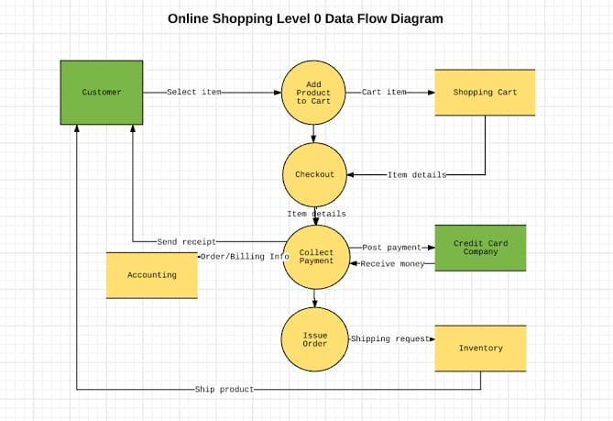

**E-R diagram**

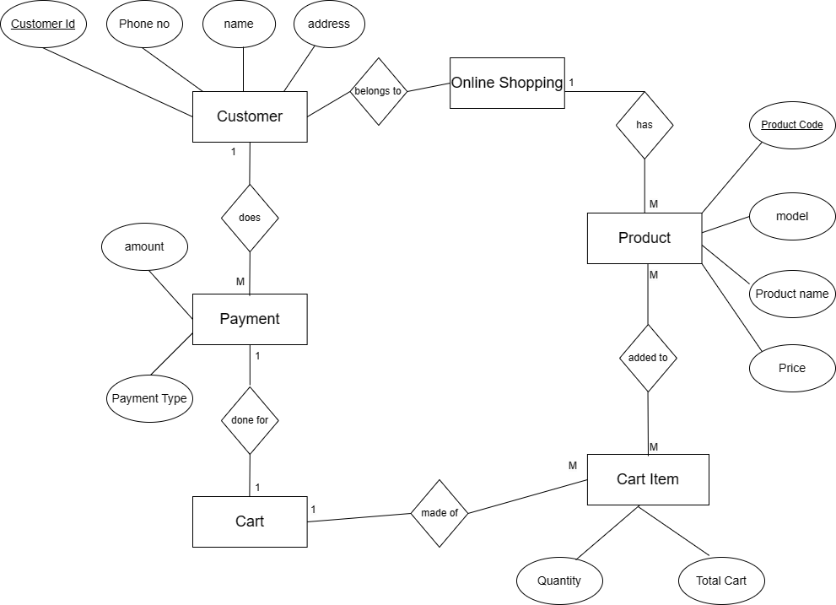

**UML diagram**

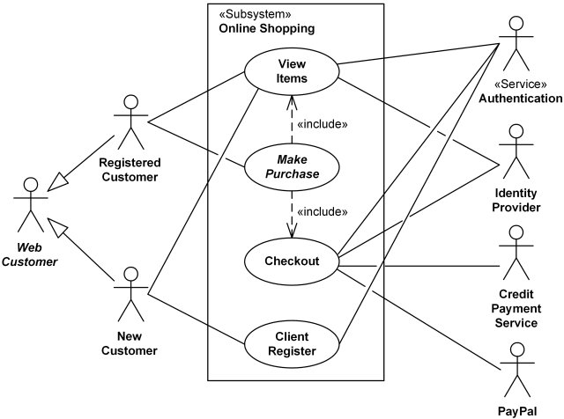

**Structural Diagram:-**

**Class Diagram**

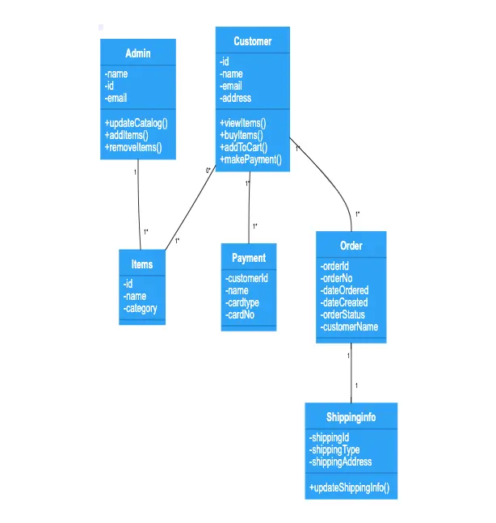

**Component Diagram**

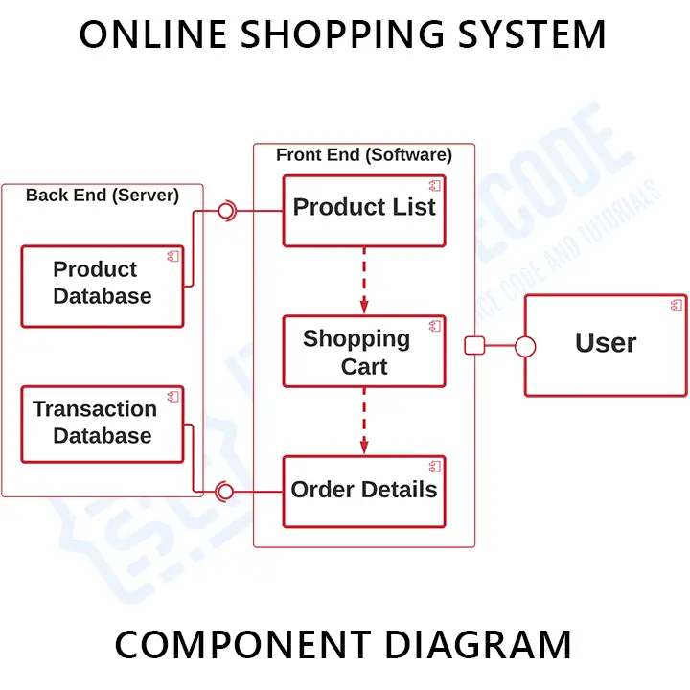

**Deployment Diagram**

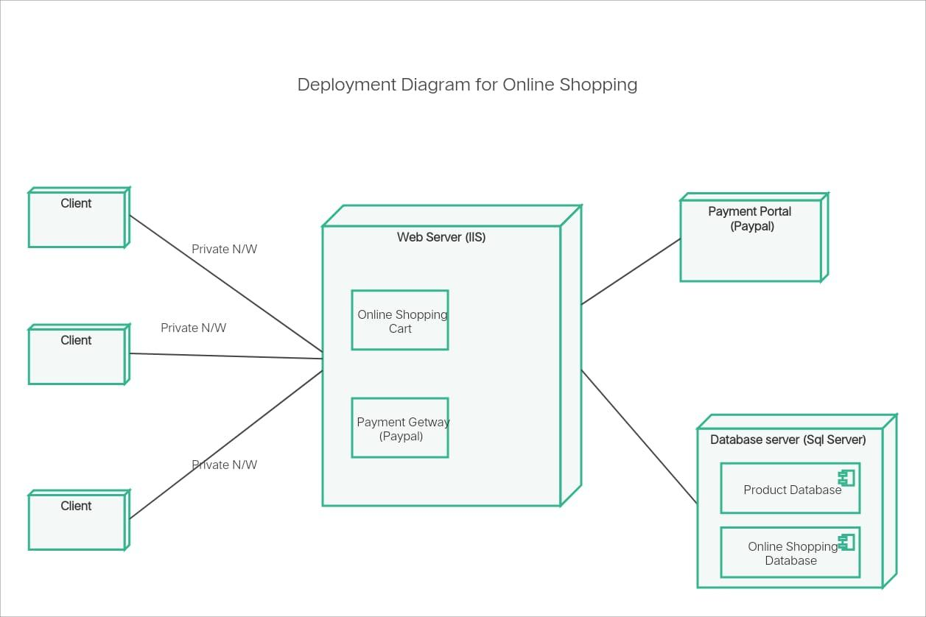

**Object diagram:-**

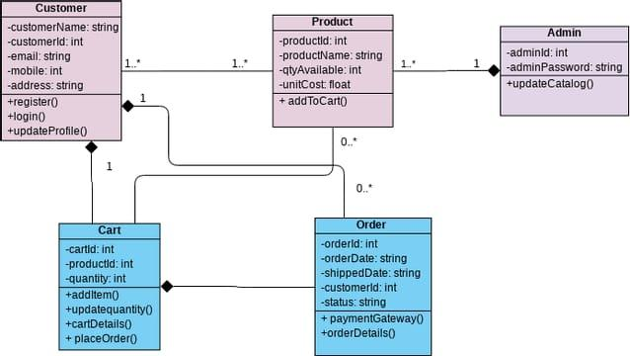

**Behaviroual diagram**

**Activity diagram:-**

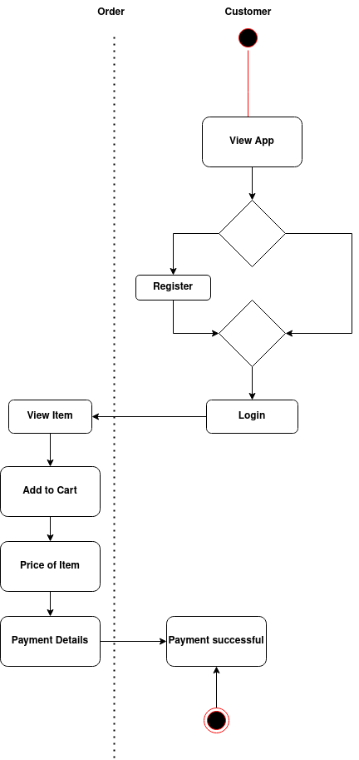

**Use-case diagram:-**

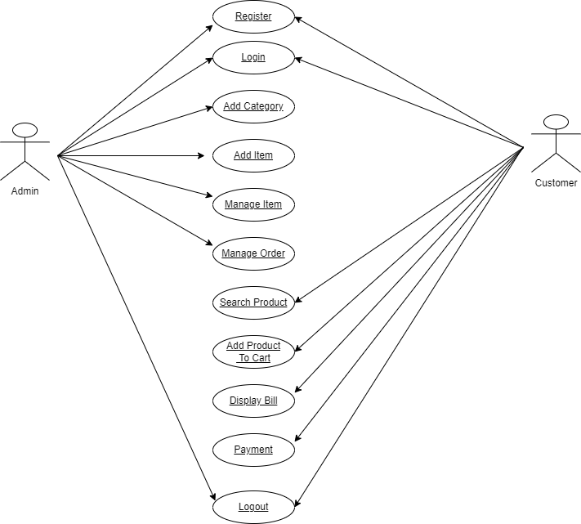

**Sequence diagram:-**

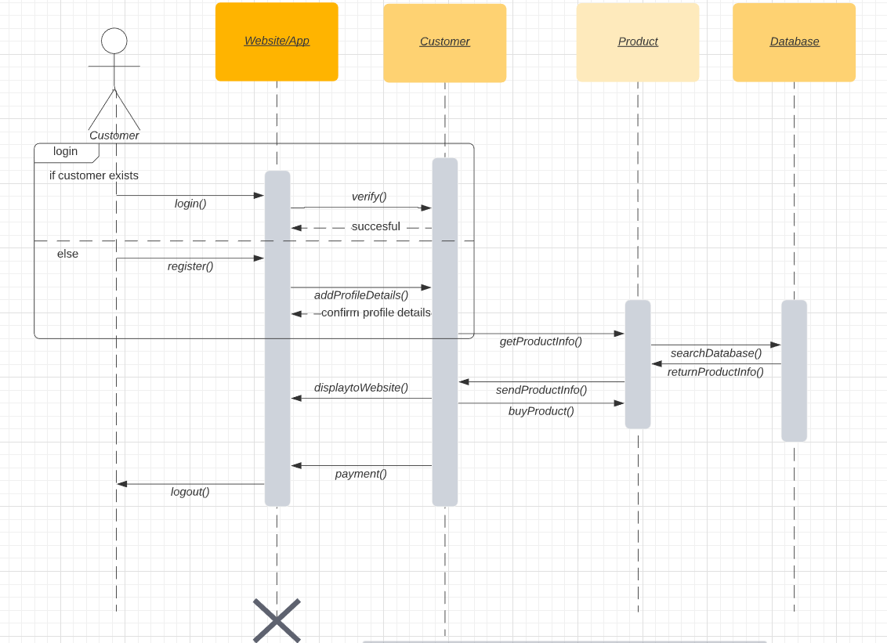

**Sample Code: -**

**Website Code**

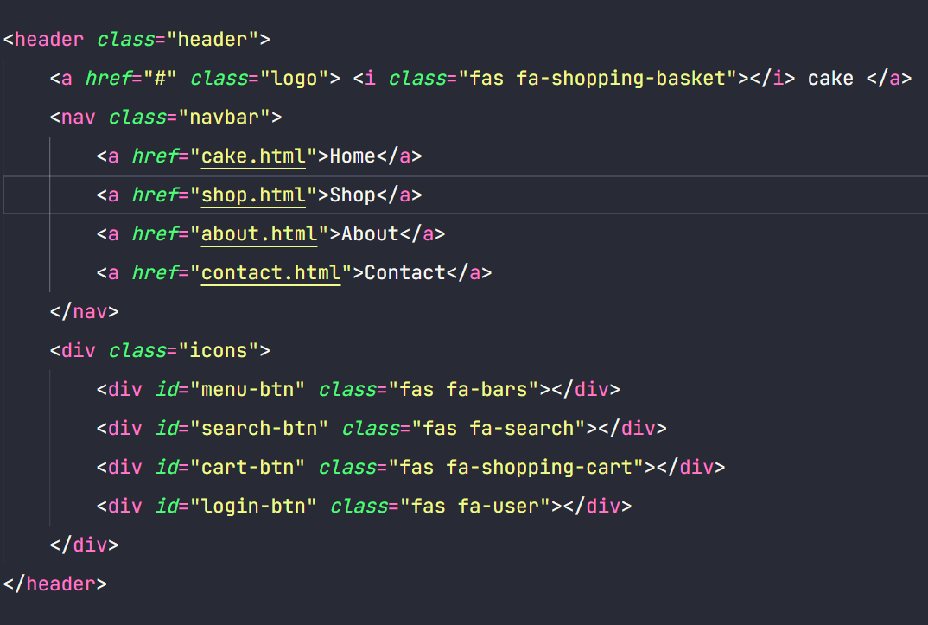

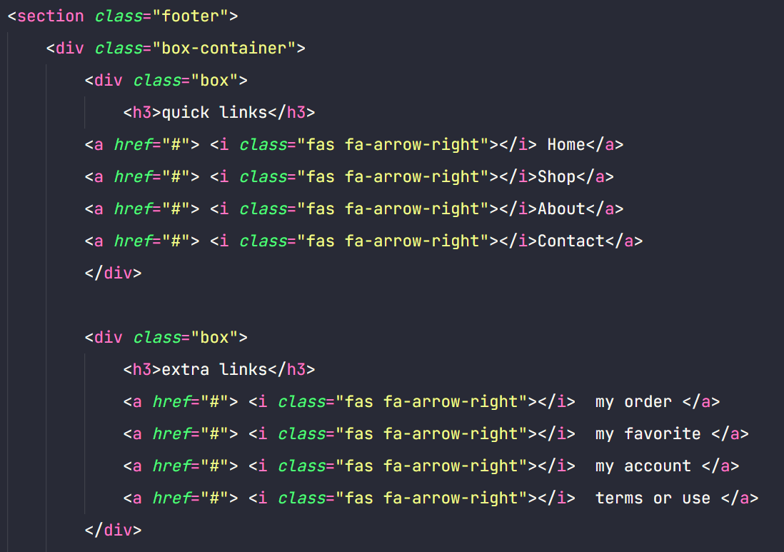

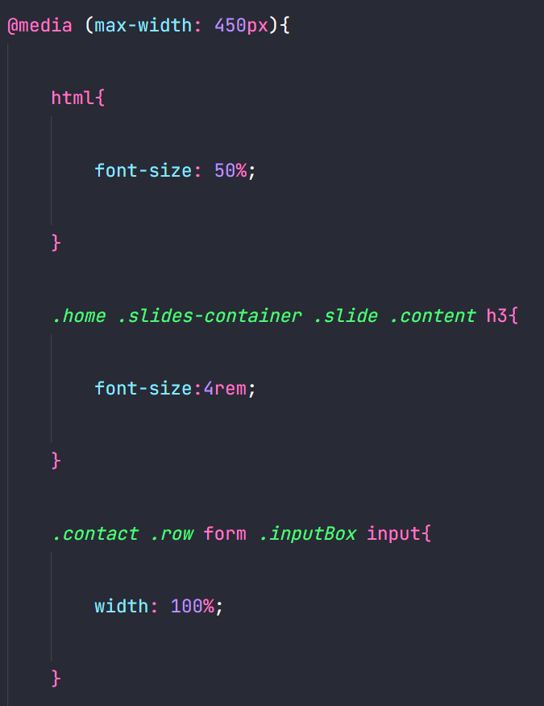

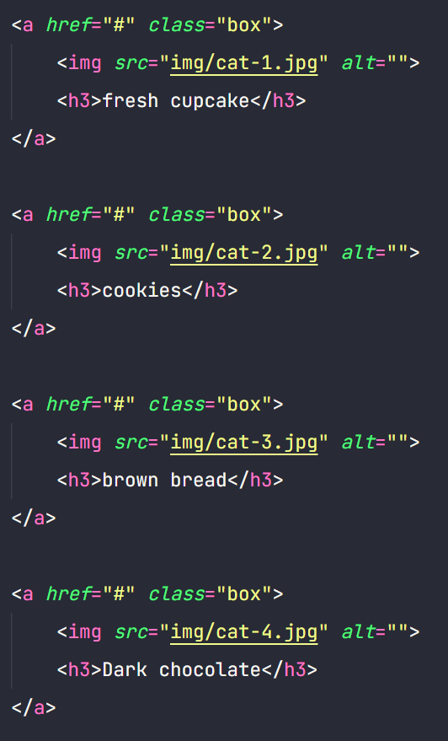

**Testing**

**Test Cases-**

Unit Test Case: Verify that the login function works correctly by checking if a user can successfully log in with the correct credentials and if an error message is displayed when incorrect credentials are entered.

Functional Test Case: Verify that the payment gateway works correctly by checking if the payment process is smooth and the payment is processed successfully without any errors or glitches.

User Acceptance Test Case: Verify that the app meets the end-users' needs and expectations by testing it with a group of users and gathering their feedback and suggestions for improvement.

Sure, here are some sample test cases for an e-commerce website:

1. Verify that the user is able to login with valid credentials.

2. Verify that the user is unable to login with invalid credentials.

3. Verify that the user is able to search for products by keyword.

4. Verify that the user is able to filter search results by category, price range, etc.

5. Verify that the user is able to add items to their cart.

6. Verify that the user is able to remove items from their cart.

7. Verify that the user is able to view their cart and its contents.

8. Verify that the user is able to checkout and submit an order.

Note: These test cases are just examples and may not be comprehensive for your specific e-commerce website.

**Test Results:-**

**Website Homepage**

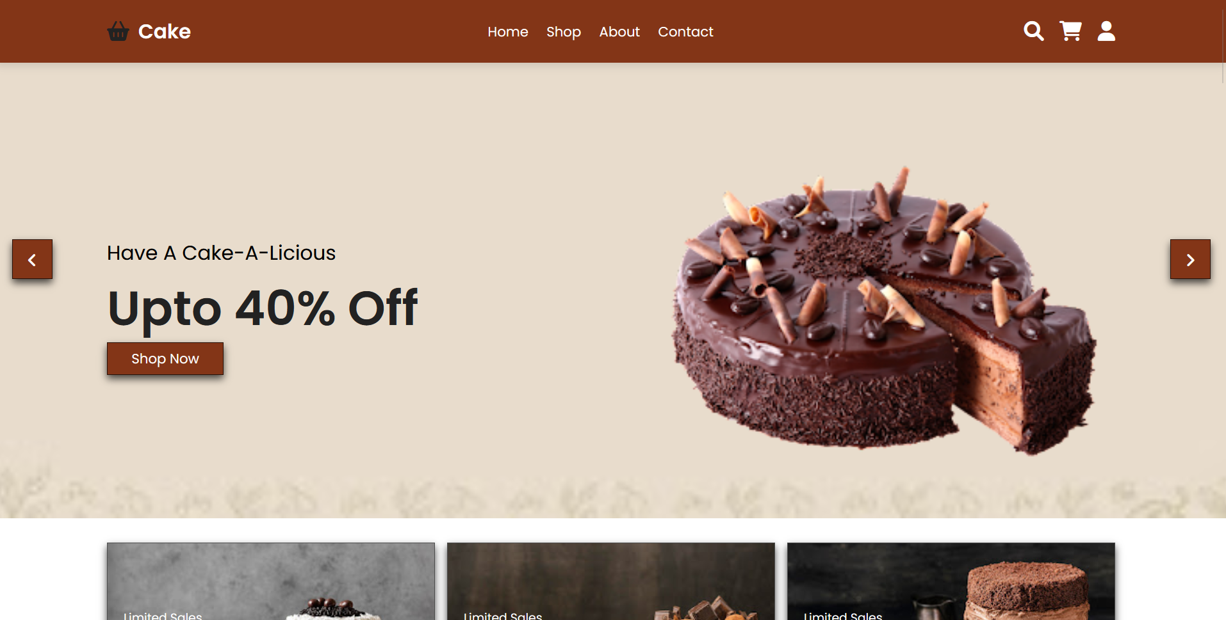

**Shopping Product**

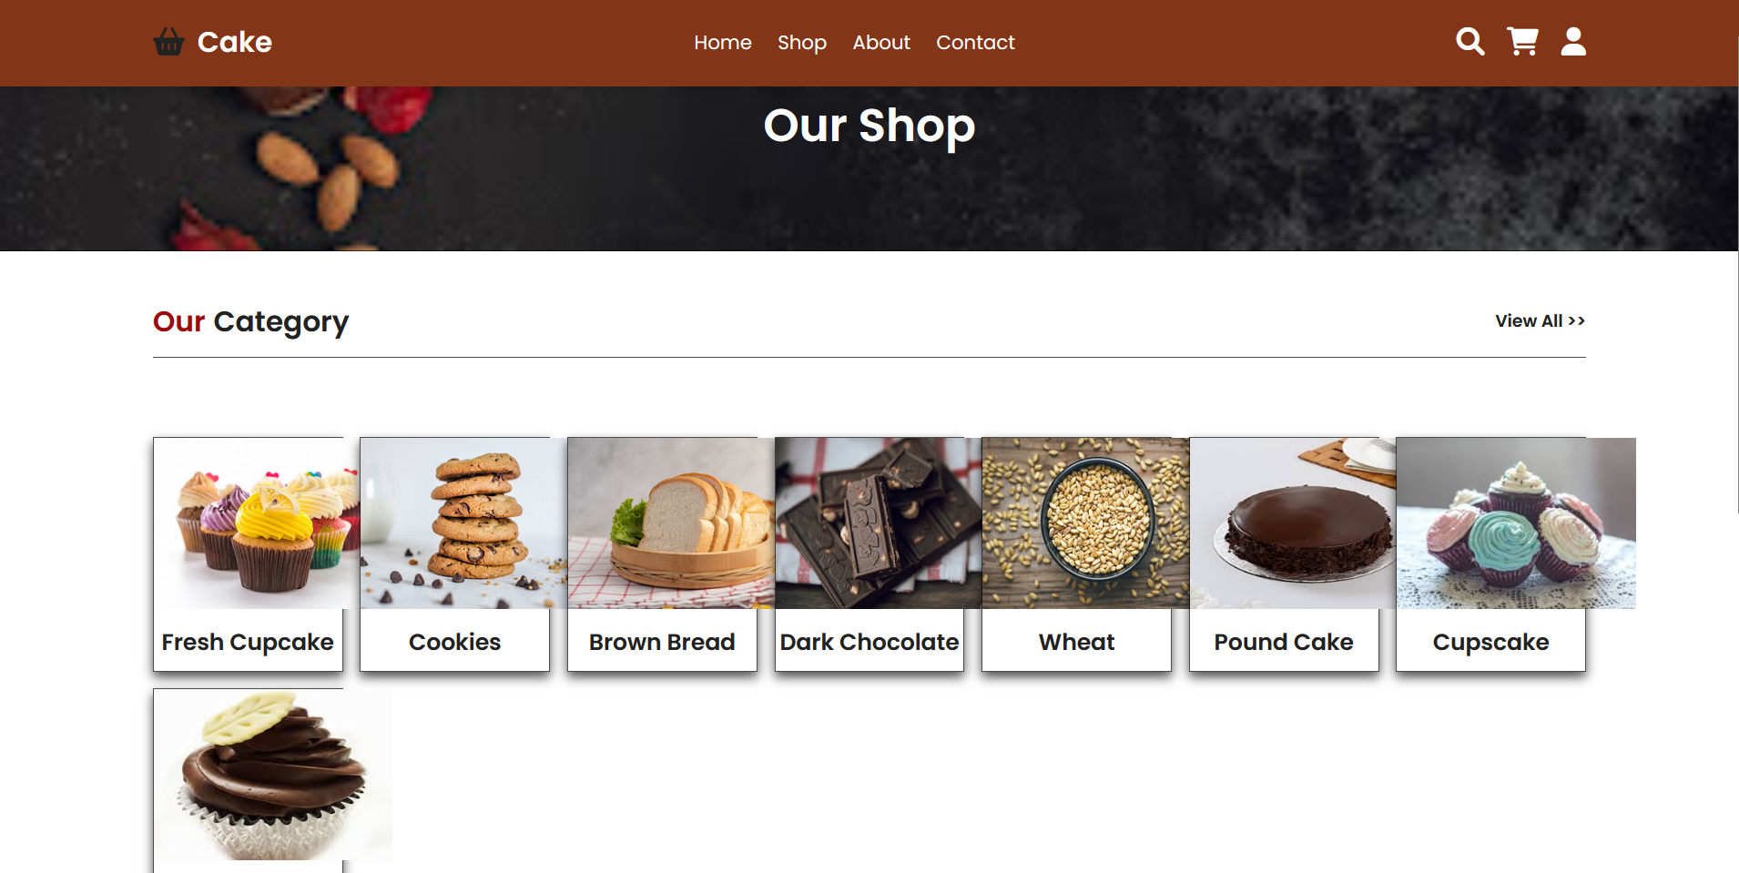

**Website Details/Footer**

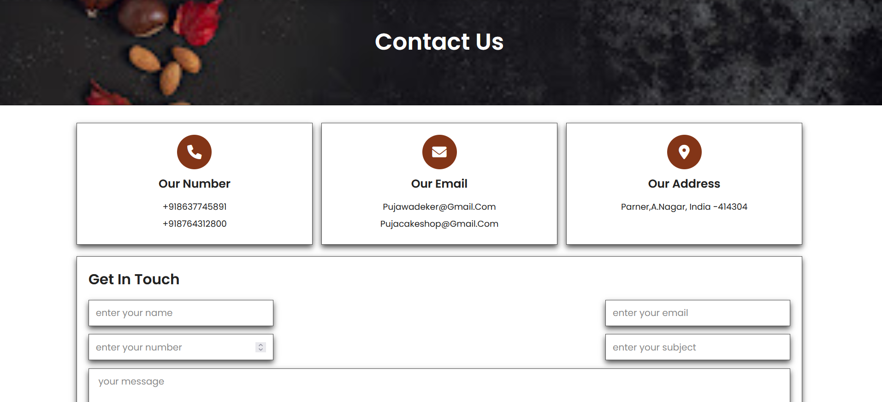

**Future Scope**

The future of cake shops holds exciting possibilities as the industry adapts to emerging trends and embraces innovative strategies. With the increasing reliance on online platforms, the potential for expanding e-commerce services and enhancing digital experiences is considerable. Personalization is likely to play a pivotal role, with advancements in technology enabling customers to create customized cake designs through interactive tools. As consumer preferences continue to evolve, there is an opportunity for cake shops to explore unique flavors, designs, and specialized dietary options, catering to a diverse clientele. Sustainability will likely become a focal point, with eco-friendly practices and locally sourced ingredients aligning with the growing awareness of environmental concerns. Community engagement will remain essential, and collaborations with local businesses or participation in events can foster stronger ties. The integration of technology, such as artificial intelligence for enhanced customer service and augmented reality for virtual experiences, will elevate the overall customer journey. Additionally, considering global expansion, franchising, or opening new branches could open doors to tapping into different markets. As the cake shop industry evolves, embracing these trends and staying attuned to customer preferences will undoubtedly contribute to long-term success and continued delight for cake enthusiasts.

**Conclusion**

In conclusion, the envisioned cake shop project represents not only a delectable venture into the world of confectionery but a testament to the dynamic and evolving nature of the culinary industry. With a commitment to quality, innovation, and customer satisfaction, our project aims to carve a niche in the local market and beyond. The comprehensive business plan, which includes a diverse product offering, online presence, and community engagement strategies, forms the foundation for a thriving and sustainable enterprise.

As we embark on this journey, the project's success will hinge on the seamless integration of technology, from a user-friendly website and efficient e-commerce system to cutting-edge tools like augmented reality for virtual experiences. The anticipation of future trends, such as personalized cake design tools, sustainability initiatives, and specialized dietary options, underscores our commitment to staying ahead of consumer preferences.

Furthermore, the cake shop's role as a community hub, engaging with local businesses and participating in events, adds a layer of social responsibility to our venture. As we strive for excellence in every aspect, from the flavors and designs of our cakes to the training and development of our staff, we aim to create not just a business but an experience that lingers in the hearts and taste buds of our customers.

**References**

Here are some references that may be useful for further reading on cake shop website development:

1. https://www.w3schools.com/

2. https://www.javatpoint.com/

3. https://stackoverflow.com/